|  |  |
| --- | --- |
| **Ex No:01** | **Develop a portfolio website for yourself which gives details about yourself for a potential recruiter.** |
| **Date:** |

**Aim:**

To develop a portfolio website for ourself which gives details about ourself for a potential recruiter.

**Algorithm:**

Step 1 : Start the program

Step 2 : Create general structure in html

Step 3 : Under <header>, <nav>, <ul>, create links for index.html, second.html, third.html.

Step 4 : Create unordered list for profile

Step 5 : In the second.html, insert images of certificates and projects done

Step 6 : In middle.html, write code to display professional experience using <ul>

Step 7 : In third.html, write code to display the contact details

Step 8 : Apply css to the header, unordered list,body to decorate the page

Step 9 : Stop the program

**Program:**

**Index.html**

<!DOCTYPE html>

<html>

<head>

<title>My Personal Information System</title>

<link rel="stylesheet" href="style.css">

</head>

<body>

<header>

<h1>Welcome to My Personal Information System</h1>

<nav>

<ul>

<li><a href="index.html">Home</a></li>

<li><a href="about.html">About</a></li>

<li><a href="edu.html">Education</a></li>

<li><a href="skills.html">Skills</a></li>

<li><a href="certifications.html">Achievements</a></li>

</ul>

</nav>

</header>

<div class="h-img">

<img class="home-img" src="image.jpg" alt="My Image" >

</div>

<footer>

<p>&copy; 2023 My Personal Information System</p>

</footer>

</body>

</html>

**About.html**

<!DOCTYPE html>

<html>

<head>

<title>My Personal Information System</title>

<link rel="stylesheet" href="style.css">

<style>

.contact-info {

display: flex;

align-items: center;

margin-top: 20px;

}

.contact-info img {

width: 20px;

height: 20px;

margin-right: 10px;

}

</style>

</head>

<body>

<header>

<h1>Welcome to My Personal Information System</h1>

<nav>

<ul>

<li><a href="index.html">Home</a></li>

<li><a href="about.html">About</a></li>

<li><a href="edu.html">Education</a></li>

<li><a href="skills.html">Skills</a></li>

<li><a href="certifications.html">Achievements</a></li>

</ul>

</nav>

</header>

<main>

<h2>About Me</h2>

<div class="about-container">

<div class="photo">

<img src="pics.jpg" alt="Balaji's Photo">

</div>

<div class="details">

<p>Hi, my name is <strong>Balaji</strong>. I am a <strong>Student</strong> at <strong>DR.NGPIT</strong> from

<strong>Coimbatore</strong>.

I am interested in <strong>Full Stack Web designing and openCV</strong>.

Dedicated and hardworking individual consistently striving to enhance my knowledge and skills.

Committed to personal growth and development,

I maintain a strong sense of self-confidence.

I am constantly engaged in refining my abilities and seeking opportunities to excel professionally.</p>

</div>

</div>

<div class="contact-info">

<img src="phone-icon.png" alt="Phone Icon">

<p>Phone: +91 63835 79334</p>

</div>

<div class="contact-info">

<img src="github-icon.png" alt="GitHub Icon">

<p>GitHub: <a href="https://github.com/rc-balaji">rc-balaji</a></p>

</div>

<div class="contact-info">

<img src="email-icon.png" alt="Email Icon">

<p>Email: rcbalaji2003@gmail.com</p>

</div>

<div class="contact-info">

<img src="linkedin-icon.png" alt="LinkedIn Icon">

<p>LinkedIn: <a href="www.linkedin.com/in/rc-balaji-5a848b248">RC Balaji</a></p>

</div>

</main>

<footer>

<p>&copy; 2023 My Personal Information System</p>

</footer>

</body>

</html>

**Certificates.html**

<!DOCTYPE html>

<html>

<head>

<title>My Personal Information System</title>

<link rel="stylesheet" href="style.css">

</head>

<body>

<header>

<h1>Welcome to My Personal Information System</h1>

<nav>

<ul>

<li><a href="index.html">Home</a></li>

<li><a href="about.html">About</a></li>

<li><a href="edu.html">Education</a></li>

<li><a href="skills.html">Skills</a></li>

<li><a href="certifications.html">Achievements</a></li>

</ul>

</nav>

</header>

<div class="main" style="margin: 8px;">

<h3>NPTEL Certifications:-</h3>

<p>

NATIONAL PROGRAMME ON TECHNOLOGY ENHANCED LEARNING [1] NPTEL is a quality Indian e-learning platform for university-level science, technology, engineering, and mathematics (STEM) subjects. It is jointly developed by Indian Institutes of Technology and Indian Institute of Science.

</p>

<ol>

<li>

<strong>Problem Solving and Programming in C (81%-Elite with Silver)</strong><br>

- A comprehensive course offered by NPTEL that focuses on developing problem-solving skills and programming proficiency in the C language, covering topics such as algorithms and efficient coding techniques.

</li>

<li>

<strong>Programming in Java (72%-Elite)</strong><br>

- An NPTEL course that provides a comprehensive understanding of Java programming, covering essential topics such as object-oriented programming, computer networks, database connectivity using JDBC, and more

</li>

</ol>

<h3>Mathworks Certifications:-</h3>

<p>MathWorks is an American privately held corporation that specializes in mathematical computing software. Its major products include MATLAB and Simulink, which support data analysis and simulation.</p>

<ol>

<li><strong>Matlab onramp</strong><br>- An introductory-level certification program by MathWorks for learning and getting started with Matlab, covering basic programming, data manipulation, and visualization.</li>

<li><strong>Machine learning onramp</strong><br>- A certification program offered by MathWorks that provides an introduction to machine learning using Matlab, covering key concepts, algorithms, and techniques for building and training machine learning models</li>

<li><strong>Solving ordinary Differential equation with MATLAB</strong><br>- A course or certification that focuses on using MATLAB to solve ordinary differential equations, covering various numerical methods, techniques, and algorithms for analyzing and solving differential equations in scientific and engineering applications.</li>

</ol>

<h3>Participations:-</h3>

<ol>

<li>Hackathon held at KGISL IT (CBE)</li>

<li>Project Presentation Contest held at BIT (ERD)</li>

<li>Paper Presentation Contest held at SKCET (CBE)</li>

<li>Ideathon held at DR.NGP IT (CBE)</li>

</ol>

</div>

<footer>

<p>&copy; 2023 My Personal Information System</p>

</footer>

</body>

</html>

**Contact.html**

<!DOCTYPE html>

<html>

<head>

<title>My Personal Information System</title>

<link rel="stylesheet" href="style.css">

</head>

<body>

<header>

<h1>Welcome to My Personal Information System</h1>

<nav>

<ul>

<li><a href="index.html">Home</a></li>

<li><a href="about.html">About</a></li>

<li><a href="edu.html">Education</a></li>

<li><a href="skills.html">Skills</a></li>

<li><a href="certifications.html">Achievements</a></li>

</ul>

</nav>

</header>

<main>

<h2 style="margin-top: 80px;">Contact Me</h2>

<form class="form" onsubmit="alert('Sent Succesfully!!!')">

<label style="width: 400px;" for="name">Name</label>

<input style="width: 400px;" type="text" id="name" required>

<label for="email">Email</label>

<input type="text" id="email"required>

<label for="message">Message</label>

<textarea id="message" placeholder="Type your message here" required></textarea>

<button type="submit" >Submit</button>

</form>

</main>

<footer>

<p>&copy; 2023 My Personal Information System</p>

</footer>

</body>

</html>

**Edu.html**

<!DOCTYPE html>

<html>

<head>

<title>My Personal Information System</title>

<link rel="stylesheet" href="style.css">

</head>

<body>

<header>

<h1>Welcome to My Personal Information System</h1>

<nav>

<ul>

<li><a href="index.html">Home</a></li>

<li><a href="about.html">About</a></li>

<li><a href="edu.html">Education</a></li>

<li><a href="skills.html">Skills</a></li>

<li><a href="certifications.html">Achievements</a></li>

</ul>

</nav>

</header>

<main>

<h2 style="margin-top: 80px;">Contact Me</h2>

<form class="form" onsubmit="alert('Sent Succesfully!!!')">

<label style="width: 400px;" for="name">Name</label>

<input style="width: 400px;" type="text" id="name" required>

<label for="email">Email</label>

<input type="text" id="email"required>

<label for="message">Message</label>

<textarea id="message" placeholder="Type your message here" required></textarea>

<button type="submit" >Submit</button>

</form>

</main>

<footer>

<p>&copy; 2023 My Personal Information System</p>

</footer>

</body>

</html>

**Skills.html**

<!DOCTYPE html>

<html lang="en">

<head>

<title>Document</title>

<link rel="stylesheet" href="style.css">

<style>

/* Internal CSS styles */

.Items {

display: flex;

flex-direction: column;

align-items: flex-start;

margin: 20px;

}

.Items h3 {

font-size: 18px;

margin-bottom: 10px;

}

.Items ul {

margin: 0;

padding: 0;

list-style-type: none;

display: flex;

flex-wrap: wrap;

gap: 20px;

}

.Items ul li .portfolio__img {

max-width: 80px;

height: auto;

margin-right: 20px;

}

.Items ul li .name {

font-weight: bold;

}

.Items ul li .description {

display: none;

}

.Items ul li:active .description {

display: block;

}

.Items ul li {

font-size: 20px;

margin-bottom: 20px;

border: 1px solid #ccc;

padding: 20px;

display: flex;

align-items: center;

width: 300px;

transition: all 0.2s ease;

}

.Items ul li:hover {

transform: scale(1.05);

}

</style>

</head>

<body>

<header>

<h1>Welcome to My Personal Information System</h1>

<nav>

<ul>

<li><a href="index.html">Home</a></li>

<li><a href="about.html">About</a></li>

<li><a href="edu.html">Education</a></li>

<li><a href="skills.html">Skills</a></li>

<li><a href="certifications.html">Achievements</a></li>

</ul>

</nav>

</header>

<div class="Items">

<h3>Programming Languages:</h3>

<ul>

<li>

<img src="java_pic.png" alt="" class="portfolio__img">

<div>

<span class="name">Java</span>

<span class="description">Java is a popular programming language that is known for its versatility and portability.</span>

</div>

</li>

<li>

<img src="python_pic.jpeg" alt="" class="portfolio__img">

<div>

<span class="name">Python</span>

<span class="description">Python is a high-level, interpreted programming language that emphasizes code readability and simplicity. </span>

</div>

</li>

<li>

<img src="c_cpp_pic.png" alt="" class="portfolio__img">

<div>

<span class="name">C/C++</span>

<span class="description">C/C++: C and C++ are closely related programming languages. C is a general-purpose, procedural programming language, while C++ is an extension of C that adds support for object-oriented programming.</span>

</div>

</li>

<li>

<img src="javascript_pic.png" alt="" class="portfolio__img">

<div>

<span class="name">JavaScript</span>

<span class="description">JavaScript is a high-level, interpreted programming language primarily used for developing interactive web pages and web applications.</span>

</div>

</li>

</ul>

<h3>Technical Skills:</h3>

<ul>

<li>

<img src="full_stack_pic.png" alt="" class="portfolio__img">

<div>

<span class="name">Full Stack Development</span>

<span class="description">Full stack development refers to the practice of developing both the frontend (client-side) and backend (server-side) components of a web application.</span>

</div>

</li>

<li>

<img src="iot_pic.png" alt="" class="portfolio__img">

<div>

<span class="name">Internet of Things</span>

<span class="description"> IoT refers to a network of physical devices embedded with sensors, software, and connectivity capabilities that enables them to collect and exchange data over the internet.</span>

</div>

</li>

<li>

<img src="data_science_pic.png" alt="" class="portfolio__img">

<div>

<span class="name">Data Science</span>

<span class="description"> Data science is an interdisciplinary field that involves extracting insights and knowledge from data using various scientific methods, processes, algorithms, and tools.</span>

</div>

</li>

<li>

<img src="mern_stack_pic.png" alt="" class="portfolio__img">

<div>

<span class="name">MERN stack + Electron</span>

<span class="description">MERN is an acronym that stands for MongoDB, Express.js, React, and Node.js. It represents a popular stack of technologies used for developing web applications.</span>

</div>

</li>

</ul>

<h3>Projects:</h3>

<ul>

<li>

<img src="hospital_management_pic.jpeg" alt="" class="portfolio__img">

<div>

<span class="name">Mobile Application for Hospital Management System</span>

<span class="description"> A Hospital Management System (HMS) is a software solution that streamlines and automates various administrative and operational tasks within a hospital or healthcare facility. It helps manage patient information, appointments, medical records, billing, inventory, and other essential aspects of hospital operations.</span>

</div>

</li>

<li>

<img src="seating_arrangement_pic.jpeg" alt="" class="portfolio__img">

<div>

<span class="name">Web Application for Seating Arrangement</span>

<span class="description">A seating arrangement refers to the organization and allocation of seats in a venue, such as a theater, auditorium, conference hall, or classroom. It involves assigning seats to individuals or groups to ensure proper seating arrangements and optimize space utilization.</span>

</div>

</li>

<li>

<img src="machine_monitoring_pic.jpeg" alt="" class="portfolio__img">

<div>

<span class="name">Desktop Application for Machine Monitoring System</span>

<span class="description"> A Machine Monitoring System is a software solution that tracks, monitors, and collects data from machines or equipment in real-time. It provides insights into machine performance, operational efficiency, and maintenance needs.</span>

</div>

</li>

<li>

<img src="iot_temperature_pic.png" alt="" class="portfolio__img">

<div>

<span class="name">IoT Application for Temperature Monitoring</span>

<span class="description">Temperature monitoring involves the measurement and tracking of temperature levels in real-time. It is a crucial aspect of many industries and applications, including healthcare, food storage, manufacturing, and environmental monitoring.</span>

</div>

</li>

</ul>

</div>

<footer>

<p>&copy; 2023 My Personal Information System</p>

</footer>

</body>

</html>

**Styles.css**

body {

font-family: Arial, sans-serif;

margin: 0;

padding: 0;

display: flex;

flex-direction: column;

min-height: 100vh;

}

.home-img{

height: 620px;

width: 100%;

}

header {

background-color: #333;

color: #fff;

padding: 10px;

}

header h1 {

margin: 0;

}

nav ul {

list-style: none;

margin: 0;

padding: 0;

}

nav li {

display: inline-block;

margin-right: 10px;

}

nav li a {

color: #fff;

text-decoration: none;

padding: 5px;

}

nav li a:hover {

background-color: #555;

}

main {

flex: 1;

padding: 20px;

max-width: 800px;

margin: 0 auto;

}

h2 {

margin-top: 0;

}

.form {

display: flex;

flex-direction: column;

max-width: 500px;

margin: 0 auto;

}

label {

margin-top: 10px;

}

input {

padding: 5px;

border: 1px solid #ccc;

border-radius: 3px;

margin-top: 5px;

}

button[type="submit"] {

background-color: #333;

color: #fff;

padding: 5px 10px;

border: none;

border-radius: 3px;

margin-top: 10px;

cursor: pointer;

}

button[type="submit"]:hover {

background-color: #555;

}

footer {

background-color: #333;

color: #fff;

padding: 10px;

text-align: center;

margin-top: auto;

}

footer p {

margin: 0;

}

.about-container {

display: flex;

align-items: center;

margin-bottom: 20px;

}

.photo {

width: 150px;

margin-right: 20px;

}

.photo img {

width: 100%;

display: block;

}

.details {

flex: 1;

}

**Output:-**

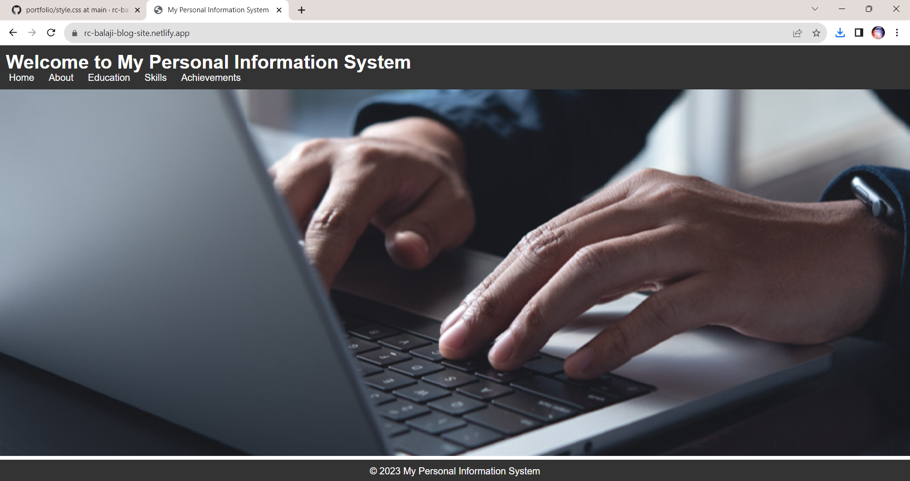

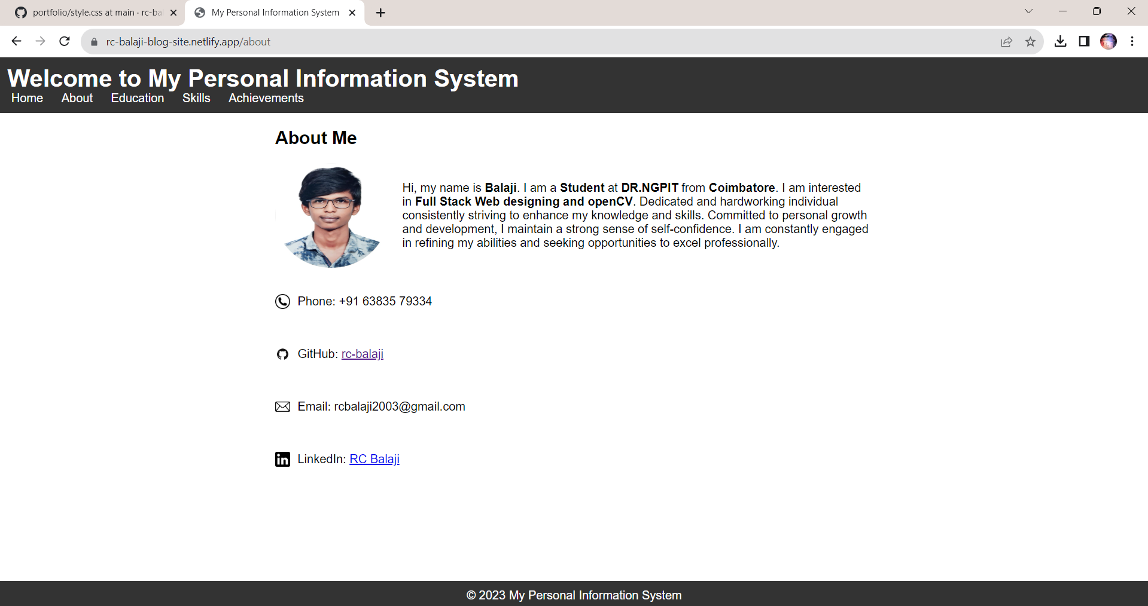

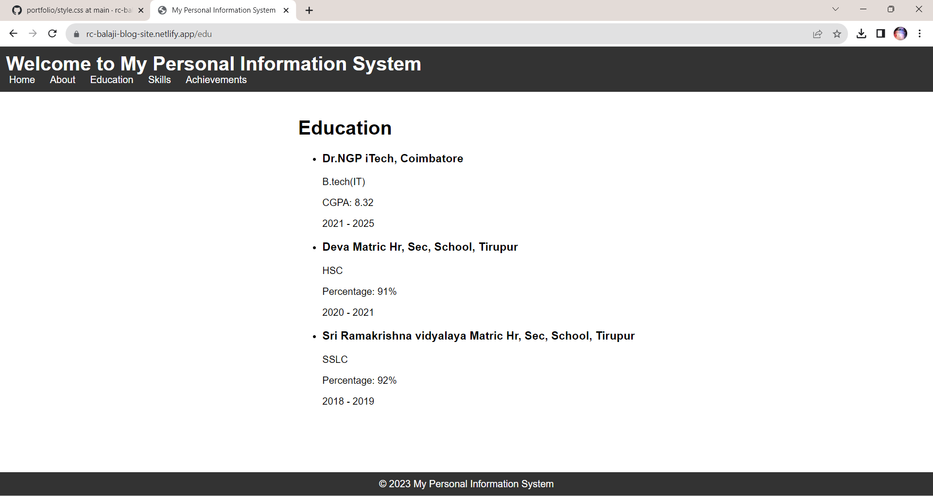

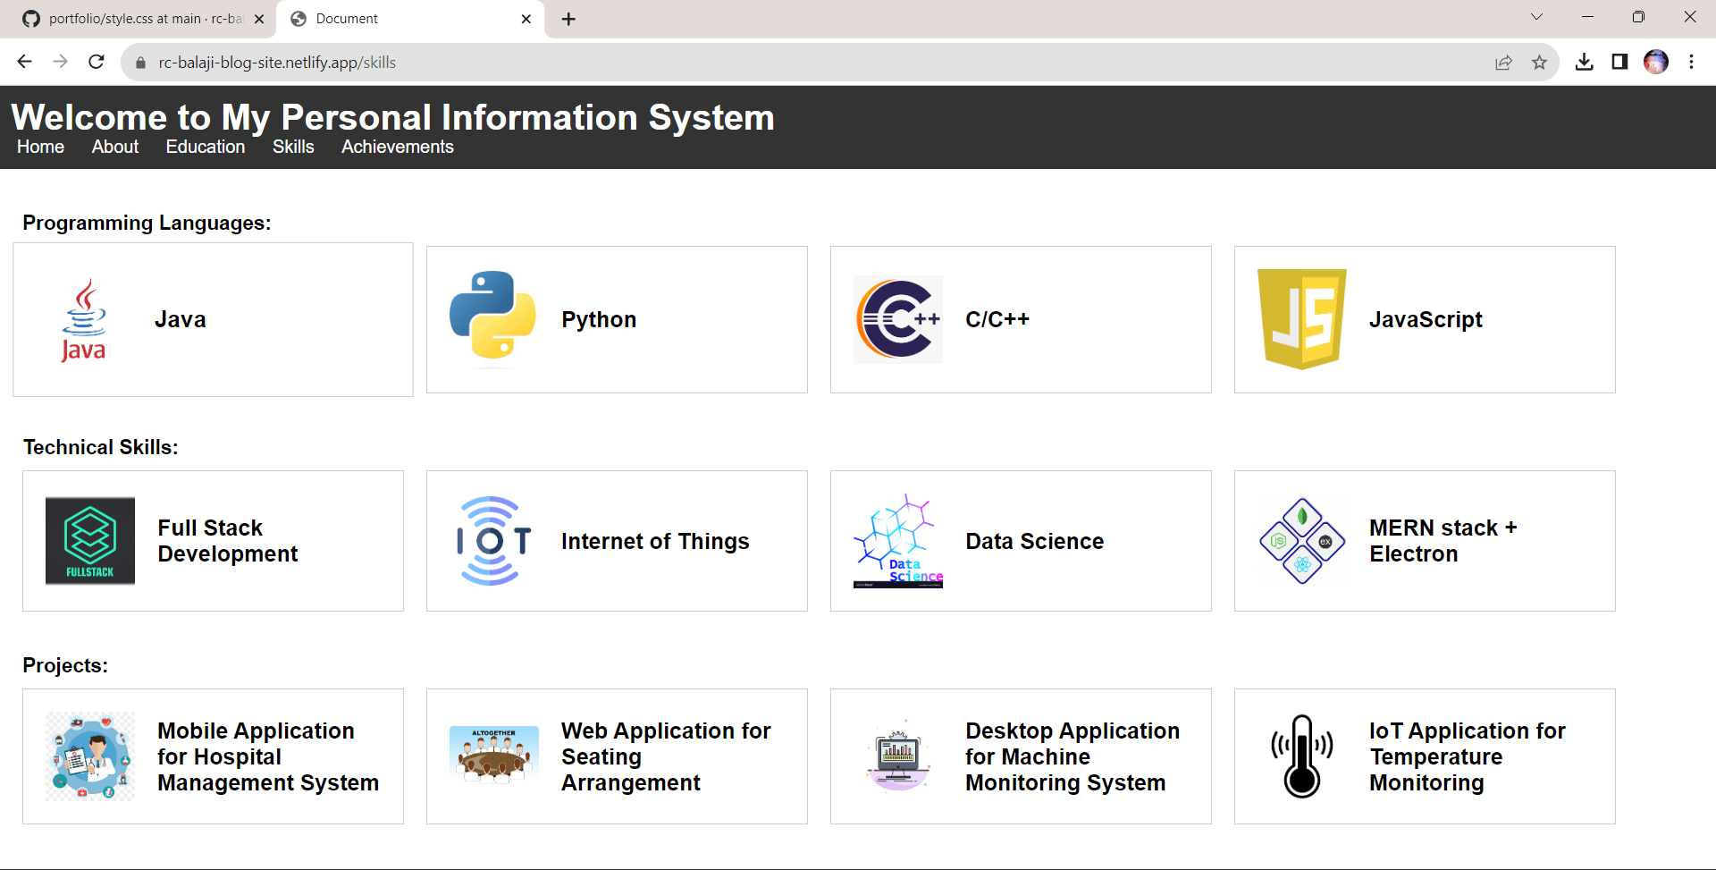

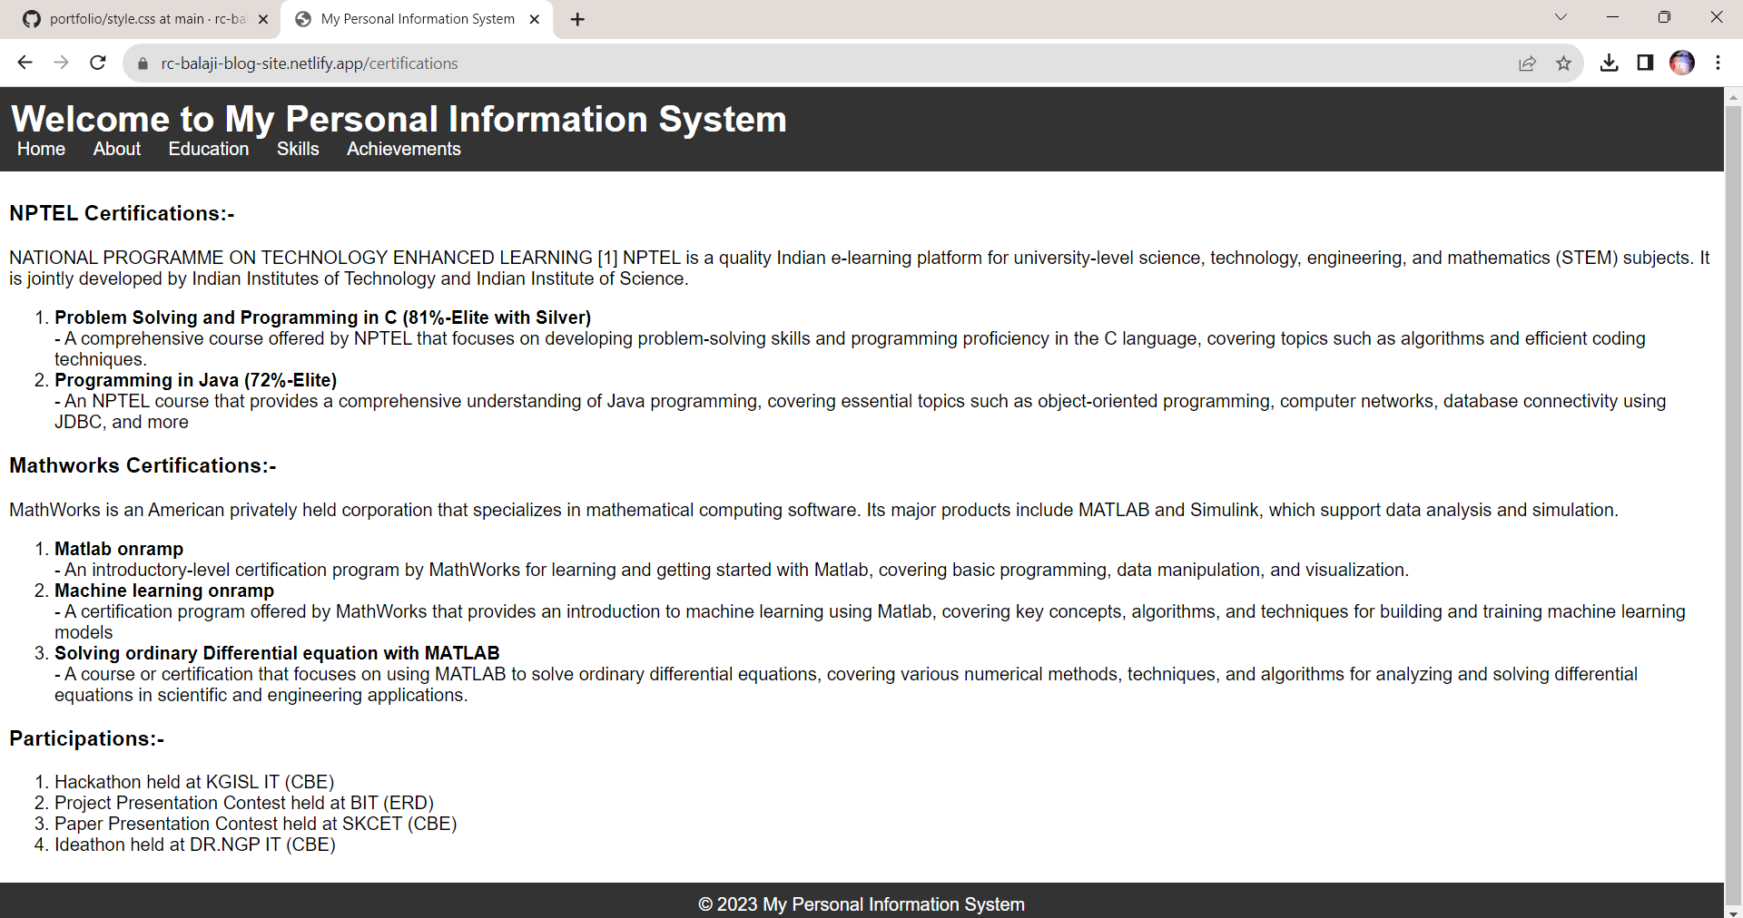

**Result:**

Thus the portfolio website has been developed successfully and the output has been verified.

|  |  |
| --- | --- |
| **Ex No:02** | **Create a web application to manage the TO-DO list of users, where users can login and manage their to-do items** |
| **Date:** |

**Aim:**

To Create a web application to manage the TO-DO list of users, where users can login and manage their to-do items.

**Algorithm:**

Step 1 : Start the program

Step 2 : Create a login page to enter into website

Step 3 : Create a page to enter task and due date with time

Step 4 : List out the entered task with due date and time

Step 5 : Provide the users with the option to mark the task as done and to delete the same for each tasks assigned

Step 6 : Using alert message, remaind the user with a beep alarm to do the tasks assigned when it is the due time

Step 7 : Stop the progarm

**Program:**

**Index.php**

<!DOCTYPE html>

<html lang="en">

<head>

<meta charset="UTF-8">

<meta http-equiv="X-UA-Compatible" content="IE=edge">

<meta name="viewport" content="width=device-width, initial-scale=1.0">

<title>To-Do List</title>

<link rel="stylesheet" href="style.css">

<style>

@import url('https://fonts.googleapis.com/css2?family=Poppins:wght@300;400;500;600;700;800;900&display=swap');

*

{

margin: 0;

padding: 0;

box-sizing: border-box;

font-family: 'Poppins', sans-serif;

}

body

{

display: flex;

justify-content: center;

align-items: center;

min-height: 100vh;

flex-direction: column;

background-image: url("bg.png");

background-repeat: no-repeat;

background-size: cover;

}

.body

{

position: relative;

width: 680px;

height: auto;

background: #1c1c1c;

border-radius: 8px;

overflow: hidden;

}

.completed-button{

text-decoration: none;

}

.top-btn,.completed-button,.complete-button{

padding: 5px 10px;

background-color: #ff5b57;

color: #fff;

border: none;

border-radius: 4px;

cursor: pointer;

}

.top-btn:hover,.completed-button:hover{

background-color:black;

}

.top-btn:hover{

background-color:black;

border: 1px solid white;

}

.top-buttons{

margin-bottom: 30px;

margin-left: 460px;

margin-top: 40px;

}

.create-todo input[type="submit"]{

border: none;

outline: none;

padding: 8px;

background-color: #9026d7;

cursor: pointer;

border-radius: 4px;

font-weight: 600;

width: 100px;

color: black;

margin-bottom: 30px;

}

.create-todo input[type="text"],

.create-todo input[type="datetime-local"] {

background-color: #45f3ff;

}

</style>

</head>

<body>

<div class="top-buttons">

<button class="top-btn" >

<a href="completed.php" class="completed-button">Completed</a></button>

<button class="top-btn"> <a href="login.php" class="completed-button">Sign Out</a></button>

</div>

<div class="body" >

<main class="app">

<section class="greeting">

<h2 class="title" style="color:#45f3ff" >

What's up, Balaji

</h2>

</section>

<section class="create-todo">

<h3 style="color:#45f3ff" >CREATE A TODO</h3>

<form action="index.php" method="post" id="new-todo-form">

<div class="task-input">

<input type="text" name="content" id="content" placeholder="e.g. finish homework" onchange="setName(this.value)" required>

</div>

<div class="datetime-input">

<input type="datetime-local" name="createdAt" id="createdAt" onchange="setDate(this.value)" required>

</div>

<div class="add-button">

<input type="submit" value="Add todo">

</div>

</form>

</section style="color:#45f3ff" >

<!-- TODO List -->

<h3 style="color:#45f3ff" >TODO LIST</h3>

<table style="background-color:#45f3ff" class="list" id="todo-list">

<tr class="list-header">

<th>S.no</th>

<th>Task</th>

<th>Deadline</th>

<th>Status</th>

</tr>

<?php echo DisplayTodos(); ?>

</table>

</section>

<!-- End of Todo List -->

</main>

</div>

<script>

function completeItem(index) {

window.location.href = 'index.php?complete=' + index;

}

function clearAll() {

if (confirm('Are you sure you want to clear all completed tasks?')) {

window.location.href = 'index.php?clearall';

}

}

function setDate(value) {

var selectedTime = value.slice(11, 16);

}

function setName(value) {

var inputName = value;

} </script>

<?php

function readTodos() {

$todos = json_decode(file_get_contents('todos.json'), true) ?: [];

return $todos;

}

function writeTodos($todos) {

file_put_contents('todos.json', json_encode($todos, JSON_PRETTY_PRINT));

}

function readCompleted() {

$completed = json_decode(file_get_contents('completed.json'), true) ?: [];

return $completed;

}

function writeCompleted($completed) {

file_put_contents('completed.json', json_encode($completed, JSON_PRETTY_PRINT | JSON_UNESCAPED_UNICODE));

}

function DisplayTodos()

{

$todos = readTodos();

$todoList = '';

$counter = 1;

if ($_SERVER['REQUEST_METHOD'] === 'POST') {

if (isset($_POST['content']) && isset($_POST['createdAt'])) {

$content = $_POST['content'];

$createdAt = $_POST['createdAt'];

if (!empty($content) && !empty($createdAt)) {

$todo = [

'content' => $content,

'done' => false,

'createdAt' => $createdAt

];

$todos[] = $todo;

writeTodos($todos);

}

header("Location: index.php");

exit();

}

}

if (isset($_GET['complete'])) {

$index = $_GET['complete'];

if (isset($todos[$index])) {

$completed = readCompleted();

$completedTodo = $todos[$index];

date_default_timezone_set('Asia/Kolkata');

$completedTodo['completedAt'] = date('Y-m-d H:i:s');

$completed[] = $completedTodo;

unset($todos[$index]);

writeCompleted($completed);

writeTodos($todos);

header("Location: index.php");

exit();

}

}

if (empty($todos)) {

$todoList .= '<tr><td colspan="4" class="no-task">No Task Available</td></tr>';

} else {

foreach ($todos as $index => $todo) {

$todoList .= '<tr class="todo-item">';

$todoList .= '<td class="sno">' . $counter . '.</td>';

$todoList .= '<td class="task">' . htmlspecialchars($todo['content']) . '</td>';

$todoList .= '<td class="deadline">';

$todoList .= 'Date: ' . date('d.m.Y', strtotime($todo['createdAt'])) . '<br>';

$todoList .= 'Time: ' . date('H:i', strtotime($todo['createdAt']));

$todoList .= '</td>';

$todoList .= '<td class="status">';

$todoList .= '<button class="complete-button" onclick="completeItem(' . $index . ')">Complete</button>';

$todoList .= '</td>';

$todoList .= '</tr>';

$counter++;

}

}

return $todoList;

}

?>

<script>

const alertsShown = {};

setInterval(checkDeadlines, 1000);

function checkDeadlines() {

const now = new Date();

const todos = <?php echo json_encode(readTodos()); ?>;

todos.forEach(todo => {

const deadline = new Date(todo.createdAt);

if (deadline < now && !alertsShown[todo.content]) {

alertsShown[todo.content] = true;

alert(`Time to ${todo.content}`);

}

});

}

</script>

</body>

</html>

**Login.php**

<!DOCTYPE html>

<html lang="en">

<head>

<meta charset="UTF-8">

<meta http-equiv="X-UA-Compatible" content="IE=edge">

<meta name="viewport" content="width=device-width, initial-scale=1.0">

<title>Login</title>

<style>

@import url('https://fonts.googleapis.com/css2?family=Poppins:wght@300;400;500;600;700;800;900&display=swap');

*

{

margin: 0;

padding: 0;

box-sizing: border-box;

font-family: 'Poppins', sans-serif;

}

body

{

display: flex;

justify-content: center;

align-items: center;

min-height: 100vh;

flex-direction: column;

background-image: url("bg.png");

background-repeat: no-repeat;

background-size: cover;

}

.box

{

position: relative;

width: 380px;

height: 420px;

background: #1c1c1c;

border-radius: 8px;

overflow: hidden;

}

@keyframes animate

{

0%

{

transform: rotate(0deg);

}

100%

{

transform: rotate(360deg);

}

}

form

{

position: absolute;

inset: 2px;

background: #28292d;

padding: 50px 40px;

border-radius: 8px;

z-index: 2;

display: flex;

flex-direction: column;

}

h2

{

color: #45f3ff;

font-weight: 500;

text-align: center;

letter-spacing: 0.1em;

}

.inputBox

{

position: relative;

width: 300px;

margin-top: 35px;

}

.inputBox input

{

position: relative;

width: 100%;

padding: 20px 10px 10px;

background: transparent;

outline: none;

box-shadow: none;

border: none;

color: #23242a;

font-size: 1em;

letter-spacing: 0.05em;

transition: 0.5s;

z-index: 10;

}

.inputBox span

{

position: absolute;

left: 0;

padding: 20px 0px 10px;

pointer-events: none;

font-size: 1em;

color: #8f8f8f;

letter-spacing: 0.05em;

transition: 0.5s;

}

.inputBox input:valid ~ span,

.inputBox input:focus ~ span

{

color: #45f3ff;

transform: translateX(0px) translateY(-34px);

font-size: 0.75em;

}

.inputBox i

{

position: absolute;

left: 0;

bottom: 0;

width: 100%;

height: 2px;

background: #45f3ff;

border-radius: 4px;

overflow: hidden;

transition: 0.5s;

pointer-events: none;

z-index: 9;

}

.inputBox input:valid ~ i,

.inputBox input:focus ~ i

{

height: 44px;

}

.links

{

display: flex;

justify-content: space-between;

}

.links a

{

margin: 10px 0;

font-size: 0.75em;

color: #8f8f8f;

text-decoration: beige;

}

.links a:hover,

.links a:nth-child(2)

{

color: #45f3ff;

}

input[type="submit"]

{

border: none;

outline: none;

padding: 11px 25px;

background: #45f3ff;

cursor: pointer;

border-radius: 4px;

font-weight: 600;

width: 100px;

margin-top: 10px;

}

input[type="submit"]:active

{

opacity: 0.8;

}

h1{

color: #45f3ff;

margin-bottom: 30px;

}

</style>

</head>

<body>

<h1>Welcome you to To-Do List</h1>

<div class="box">

<form autocomplete="off" name="myform" action="index.php" method="post" id="login-form" onsubmit="return check()">

<h2>Log in</h2>

<div class="inputBox">

<input type="text" name="username" id="username" required>

<span>Userame</span>

<i></i>

</div>

<div class="inputBox">

<input type="password" name="password" id="password" required>

<span>Password</span>

<i></i>

</div>

<div class="links">

<a href="#">Forgot Password ?</a>

<a href="#">Signup</a>

</div>

<input type="submit" value="Login">

</form>

</div>

<script>

function check() {

let user = document.forms["myform"]["username"].value;

let pass = Number(document.forms["myform"]["password"].value);

const username = ["sam", "ram", "raj"];

const password = [123, 234, 456];

t = 0;

for (let i = 0; i < 3; i++) {

if (user === username[i] && pass === password[i]) {

t = 1;

} else if (user === username[i] && pass !== password[i]) {

t = 2;

}

}

if (t === 1) {

setTimeout(function () {

document.getElementById("login-form").submit();

}, 500);

return false;

} else if (t === 2) {

alert("Incorrect Pass");

return false;

} else {

alert("Not found");

return false;

}

}

</script>

</body>

</html>

**completed.php**

<!DOCTYPE html>

<html lang="en">

<head>

<meta charset="UTF-8">

<meta http-equiv="X-UA-Compatible" content="IE=edge">

<meta name="viewport" content="width=device-width, initial-scale=1.0">

<title>Login</title>

<style>

@import url('https://fonts.googleapis.com/css2?family=Poppins:wght@300;400;500;600;700;800;900&display=swap');

*

{

margin: 0;

padding: 0;

box-sizing: border-box;

font-family: 'Poppins', sans-serif;

}

body

{

display: flex;

justify-content: center;

align-items: center;

min-height: 100vh;

flex-direction: column;

background-image: url("bg.png");

background-repeat: no-repeat;

background-size: cover;

}

.box

{

position: relative;

width: 380px;

height: 420px;

background: #1c1c1c;

border-radius: 8px;

overflow: hidden;

}

@keyframes animate

{

0%

{

transform: rotate(0deg);

}

100%

{

transform: rotate(360deg);

}

}

form

{

position: absolute;

inset: 2px;

background: #28292d;

padding: 50px 40px;

border-radius: 8px;

z-index: 2;

display: flex;

flex-direction: column;

}

h2

{

color: #45f3ff;

font-weight: 500;

text-align: center;

letter-spacing: 0.1em;

}

.inputBox

{

position: relative;

width: 300px;

margin-top: 35px;

}

.inputBox input

{

position: relative;

width: 100%;

padding: 20px 10px 10px;

background: transparent;

outline: none;

box-shadow: none;

border: none;

color: #23242a;

font-size: 1em;

letter-spacing: 0.05em;

transition: 0.5s;

z-index: 10;

}

.inputBox span

{

position: absolute;

left: 0;

padding: 20px 0px 10px;

pointer-events: none;

font-size: 1em;

color: #8f8f8f;

letter-spacing: 0.05em;

transition: 0.5s;

}

.inputBox input:valid ~ span,

.inputBox input:focus ~ span

{

color: #45f3ff;

transform: translateX(0px) translateY(-34px);

font-size: 0.75em;

}

.inputBox i

{

position: absolute;

left: 0;

bottom: 0;

width: 100%;

height: 2px;

background: #45f3ff;

border-radius: 4px;

overflow: hidden;

transition: 0.5s;

pointer-events: none;

z-index: 9;

}

.inputBox input:valid ~ i,

.inputBox input:focus ~ i

{

height: 44px;

}

.links

{

display: flex;

justify-content: space-between;

}

.links a

{

margin: 10px 0;

font-size: 0.75em;

color: #8f8f8f;

text-decoration: beige;

}

.links a:hover,

.links a:nth-child(2)

{

color: #45f3ff;

}

input[type="submit"]

{

border: none;

outline: none;

padding: 11px 25px;

background: #45f3ff;

cursor: pointer;

border-radius: 4px;

font-weight: 600;

width: 100px;

margin-top: 10px;

}

input[type="submit"]:active

{

opacity: 0.8;

}

h1{

color: #45f3ff;

margin-bottom: 30px;

}

</style>

</head>

<body>

<h1>Welcome you to To-Do List</h1>

<div class="box">

<form autocomplete="off" name="myform" action="index.php" method="post" id="login-form" onsubmit="return check()">

<h2>Log in</h2>

<div class="inputBox">

<input type="text" name="username" id="username" required>

<span>Userame</span>

<i></i>

</div>

<div class="inputBox">

<input type="password" name="password" id="password" required>

<span>Password</span>

<i></i>

</div>

<div class="links">

<a href="#">Forgot Password ?</a>

<a href="#">Signup</a>

</div>

<input type="submit" value="Login">

</form>

</div>

<script>

function check() {

let user = document.forms["myform"]["username"].value;

let pass = Number(document.forms["myform"]["password"].value);

const username = ["sam", "ram", "raj"];

const password = [123, 234, 456];

t = 0;

for (let i = 0; i < 3; i++) {

if (user === username[i] && pass === password[i]) {

t = 1;

} else if (user === username[i] && pass !== password[i]) {

t = 2;

}

}

if (t === 1) {

setTimeout(function () {

document.getElementById("login-form").submit();

}, 500);

return false;

} else if (t === 2) {

alert("Incorrect Pass");

return false;

} else {

alert("Not found");

return false;

}

}

</script>

</body>

</html>

**Output:**

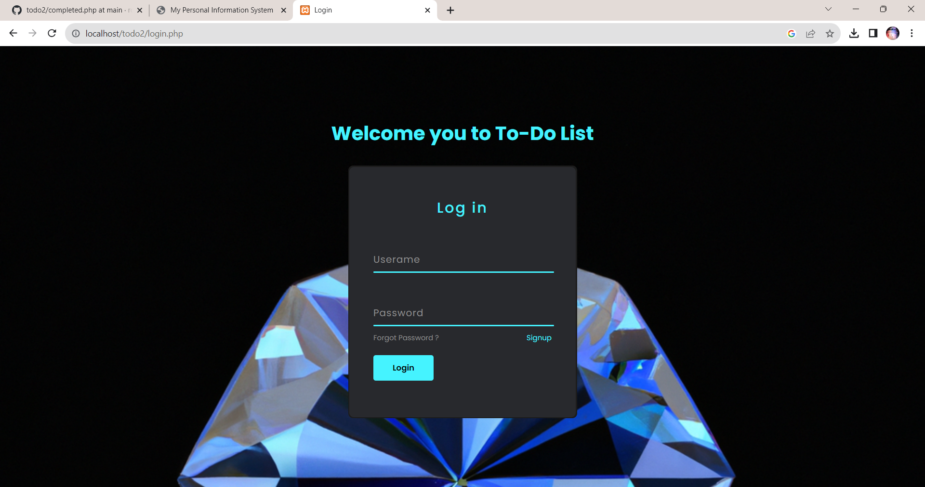

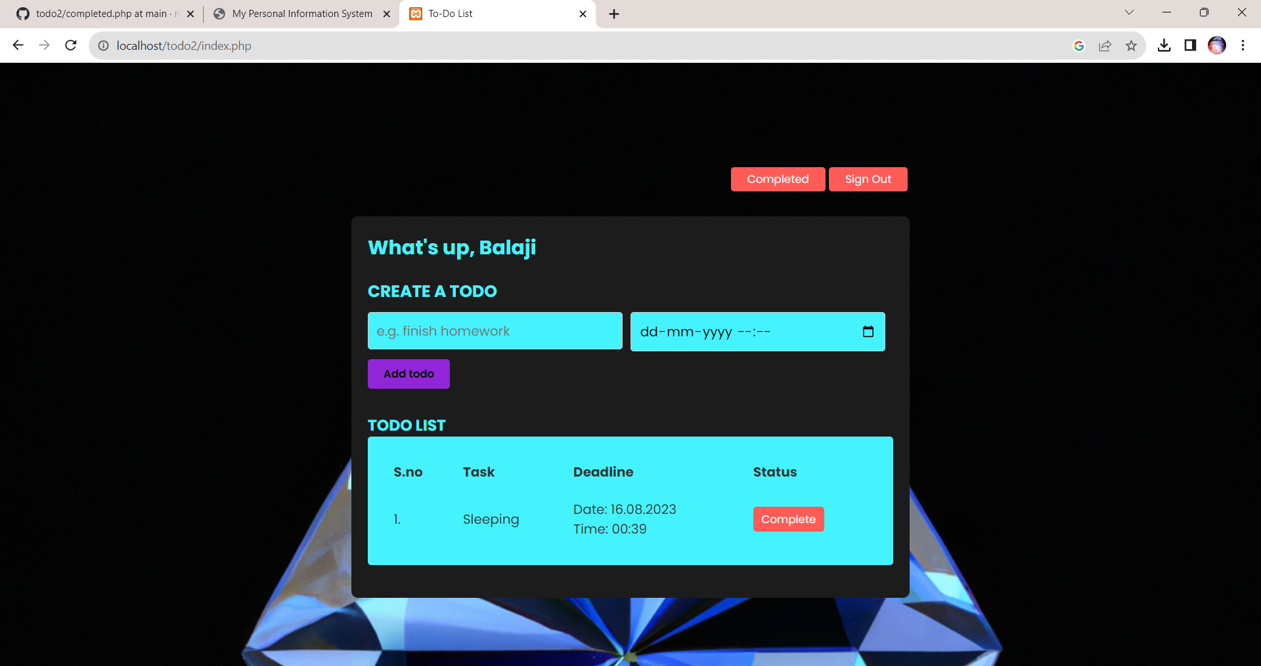

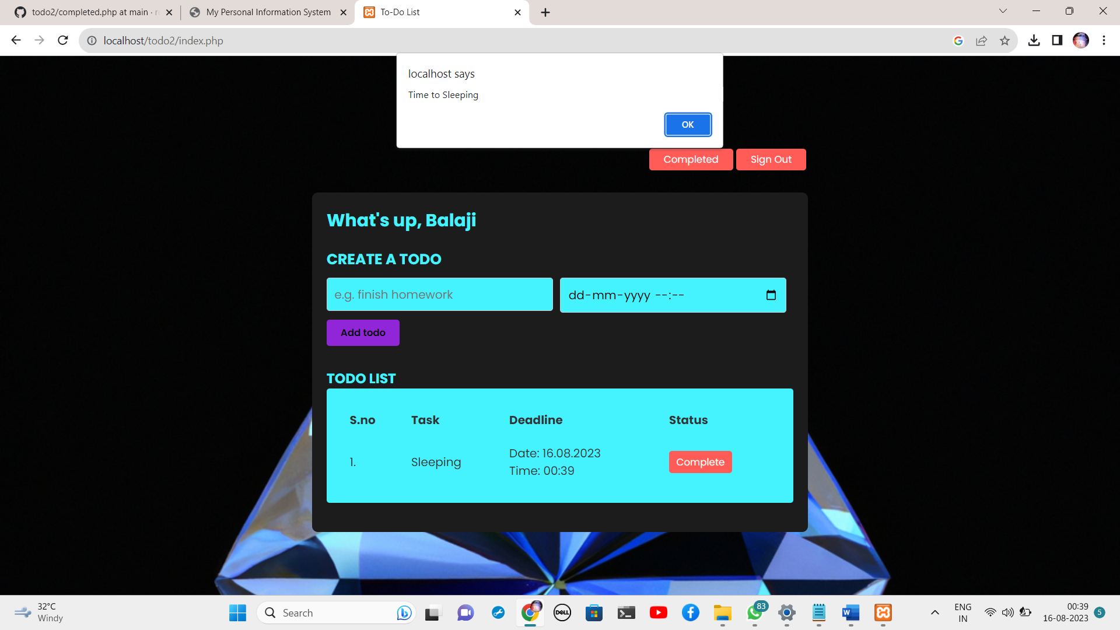

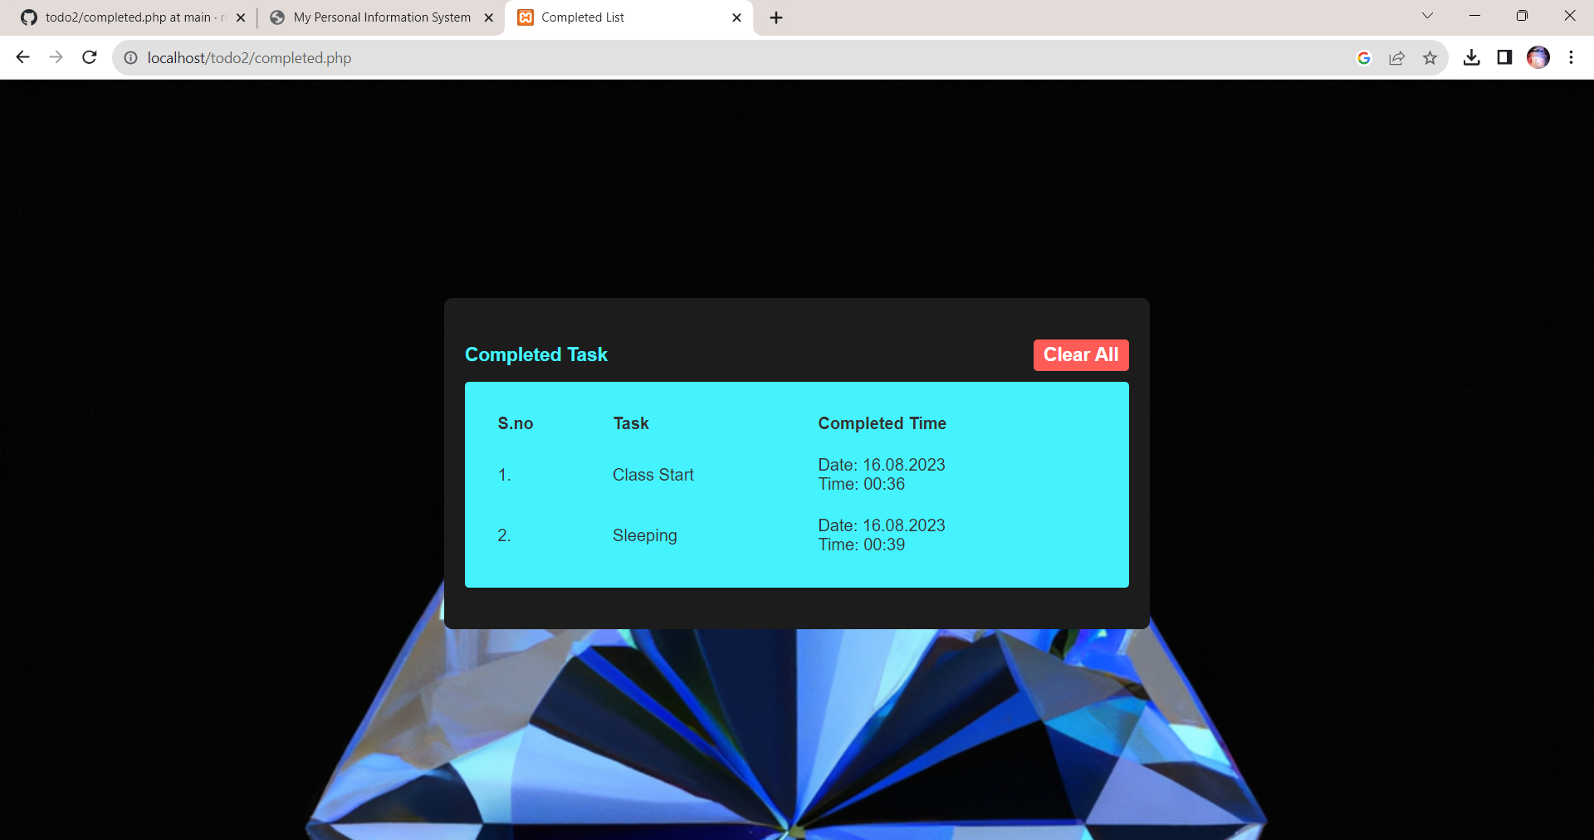

**Result:**

Thus the creation of web application to manage the todo list has been done successfully and the output

is verified.